3. Asian American Communities in Queens:

A Demographic Snapshot

Queens is the most diverse borough in New York City, shared by manyracial, ethnic, and cultural groups.

Major Asian subgroups
According to the 2010 Census, the largest Asian subgroups in Queens are Chinese and Taiwanese, Asian Indian, Korean, Filipino, and Bangladeshi. There are also sizeable populations of smaller Asian groups and diasporic Asian populations such as Indocaribbeans and Asians from Latin America (see fact sheet "Asians in Queens" for additional details).⁵

Why is Queens significant for Asian Americans?
- 49% of New York City Asians live in Queens.
- There are seven Asian-majority neighborhoods, and five of them are in Queens (Flushing, Queensboro Hill, East Flushing, Elmhurst-Maspeth, and Murray Hill).²

How much did Asian populations grow between 2000-2010?
- Asians were the fastest growing major racial/ethnic group in New York City, and was the only one to grow in all five boroughs.
- City-wide, Chinese, Bangladeshis, and Indians experienced the largest numeric increase; Hmong, Taiwanese, Bangladeshis, and Laotians experienced the largest percent increase.²
- The number of Queens residents identified as "Asian alone" increased by 120,940, or 30.9%, mirroring the increase of Asians in New York City as a whole.³
- The Queens neighborhoods experiencing largest proportional growth of "Asian nonhispanic" populations were Jamaica (75%), Douglaston-Little Neck (57%), Bayside (49%), East Flushing (45%), Queensboro Hill (45%), Richmond Hill (38%), and Murray Hill (32%).^{1,4}

Queens Neighborhoods
From 2010 Census numbers, Flushing (49,975), Elmhurst (38,929), Murray Hill (27,277), Jackson Heights (23,954), and Forest Hills (20,332) had the largest numbers of "Asian alone" in Queens. However, it is important to note the great diversity of Asians residing in Queens and different settlement patterns for each group. For example, the largest numbers of Asian Indians live in South Ozone Park, Richmond Hill, and Jackson Heights, while the largest numbers of Koreans live in Murray Hill, Flushing, and Bayside.⁶ To further explore geographical settlement of Asian subgroups by census tract, see The New York Times's interactive map of 2010 Census data.⁷
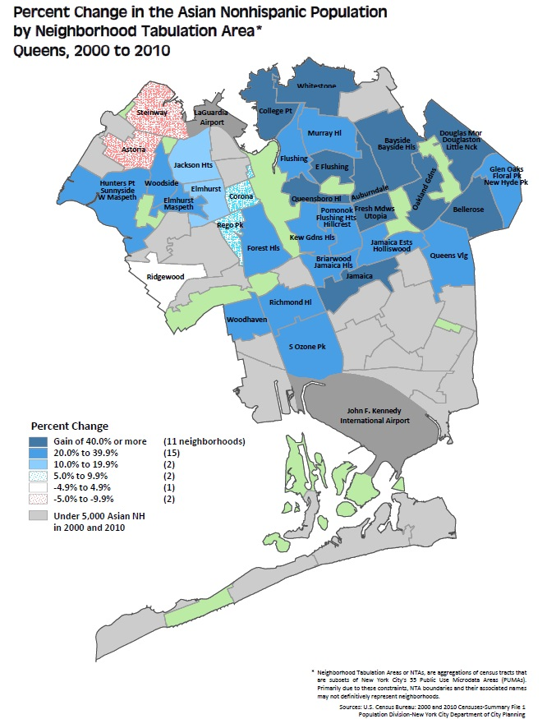

Reproduced from New York City Department of City Planning. NYC 2010 Results from the 2010 Census: Population Growth and Race/Hispanic Composition.¹

Foreign born and Citizenship status
According to the 2011 American Community Survey, nearly half of Queens residents were foreign born (1,089,187, 48.5%). Queens is home to 35.5% of New York City's foreign-born population.⁸ An extremely high proportion of Queens's Asian alone population is foreign born: 393,242 (75.7%). The majority of Queens Asians hold U.S. citizenship status (63.9%): approximately one third through birth and two thirds through naturalization (see chart below).⁹ Out of Queens immigrants born in Asia, 35.6% emigrated in 2000 or later.¹⁰
It is important to note that Asians immigrate to the United States under a variety of circumstances. Asian immigrants may enter under family reunification, student visas, or for the majority of some communities (e.g. Burmese and Bhutanese), under refugee status.² The high percentage of foreign born among Asians has major implications for the population's ability to participate in America's political, legal, healthcare, and other systems. This is due to citizenship-related eligibility, as well as unfamiliarity with and inability to navigate American systems.

Language
85.1% of Queens's Asian alone population over five years old (including both native and foreign born) speak a language other than English. 48.2% speak English less than "very well".¹¹
English-speaking ability varies greatly by Asian subgroup and age; while over 90% of New York City's Chinese, Korean, and Vietnamese-speaking senior citizen populations have limited-English

proficiency (LEP), less than 50% of Tagalog and Hindi-speakers have LEP.² While high rates of multilingualism is an asset in Asian communities, high rates of LEP present linguistic barriers to civic participation and social services.

Age and Sex
51.1% of Asians in Queens are female.¹² The median age of males is 36.5, and the median age for females is 38.2.¹³
The majority of New York City's Bangladeshi, Filipino, Indian, Korean, and Taiwanese children and senior citizens live in Queens. Chinese and Bangladeshi children accounted for the bulk of increase in Asian children in Queens from 2000 to 2006-2010 estimates. ²

Educational Attainment
Asians vary widely in educational attainment. In New York City, Asians have the second highest rate of adults with college and post-graduate degrees, as well as the second highest rate of adults with no high school diploma.²

Economic Status and Employment
86,608 (16.7%) of Queen's Asian alone population live with a household income below poverty level. Of Queens Asians living in poverty, 22.7% are children under the age of 18, and 11.1% are seniors 65 and older.¹⁴ The median household income for Queens Asian alone householders was $53,304.¹⁵
According to 2006-2010 American Community Survey estimates, Bangladeshi, Pakistani, and Vietnamese communities experienced highest rates of poverty city-wide, while Filipino communities had lowest rates.²

References and further reading
* By mutually exclusive race and Hispanic origin.
¹ New York City Department of City Planning. NYC 2010 Results from the 2010 Census: Population Growth and Race/Hispanic Composition. Retrieved May 26, 2014 from http://www.nyc.gov/html/dcp/pdf/census/census2010/pgrhc.pdf.
² Asian American Federation. (2012). Asian Americans in New York City: a Decade of Dynamic Change 2000-2010. Retrieved May 26, 2014 http://www.aafny.org/pdf/AAF_nyc2010report.pdf.
³ Retrieved May 26, 2014 from http://censusviewer.com/county/NY/Queens
⁴ New York City Department of City Planning. NYC 2010 Results from the 2010 Census: Components of Change by Race and Hispanic Origin for New York City Neighborhoods. Retrieved May 26, 2014 from http://www.nyc.gov/html/dcp/pdf/census/census_brief2_051012.pdf
⁵ New York City Department of City Planning. (2012, June). Table SF1-P9 NYC: Total Asian Population by Selected Subgroups New York City and Boroughs, 2010. Retrieved May 26, 2014 from http://www.nyc.gov/html/dcp/pdf/census/census2010/t_sf1_p9_nyc.pdf

⁶ New York City Department of City Planning. (2011). Table SF1-P9-1 NTA: Total Asian Population by Selected Subgroups New York City Neighborhood tabulation Areas, 2010. Retrieved May 26, 2014 from http://www.nyc.gov/html/dcp/pdf/census/census2010/t_sf1_p9_nta.pdf.
⁷ Fessenden, F. & Bloch, M. (2011). Asians in New York City. The New York Times. Retrieved May 26, 2014 from http://www.nytimes.com/interactive/2011/06/23/nyregion/new-york-asians.html?_r=0.
⁸ New York City Department of City Planning. (2013). The Newest New Yorkers: Characteristics of the City's Foreign-born Population. Retrieved May 26, 2014 from http://www.nyc.gov/html/dcp/pdf/census/nny2013/nny_2013.pdf.
⁹ U.S. Census Bureau. (2009-2011). Sex by Age by Nativity and Citizenship Status (Asian Alone). 2011 American Community Survey 3-Year Estimates. Retrieved from http://factfinder2.census.gov/bkmk/table/1.0/en/ACS/11_3YR/B06004D/0500000US36081
¹⁰ U.S. Census Bureau. (2009-2011). Place of Birth by Year of Entry by Citizenship Status for the Foreign-born Population. 2011 American Community Survey 3-Year Estimates. Retrieved from http://factfinder2.census.gov/bkmk/table/1.0/en/ACS/11_3YR/B05007/0500000US36081
¹¹ U.S. Census Bureau. (2009-2011). Nativity by Language Spoken at Home by Ability to Speak English for the Population 5 Years and Over (Asian Alone). 2011 American Community Survey 3-Year Estimates. Retrieved from http://factfinder2.census.gov/bkmk/table/1.0/en/ACS/11_3YR/B16005D/0500000US36081
¹² U.S. Census Bureau. (2009-2011). Sex by Age (Asian Alone). 2011 American Community Survey 3-Year Estimates. Retrieved from http://factfinder2.census.gov/bkmk/table/1.0/en/ACS/11_3YR/B01001D/0500000US36081
¹³ U.S. Census Bureau. (2009-2011). Median Age by Sex (Asian Alone). 2011 American Community Survey 3-Year Estimates. Retrieved from http://factfinder2.census.gov/bkmk/table/1.0/en/ACS/11_3YR/B01002D/0500000US36081
¹⁴ U.S. Census Bureau. (2009-2011). Poverty Status in the Past 12 Months by Age (Asian Alone). 2011 American Community Survey 3-Year Estimates. Retrieved from http://factfinder2.census.gov/bkmk/table/1.0/en/ACS/11_3YR/C17020D/0500000US36081

